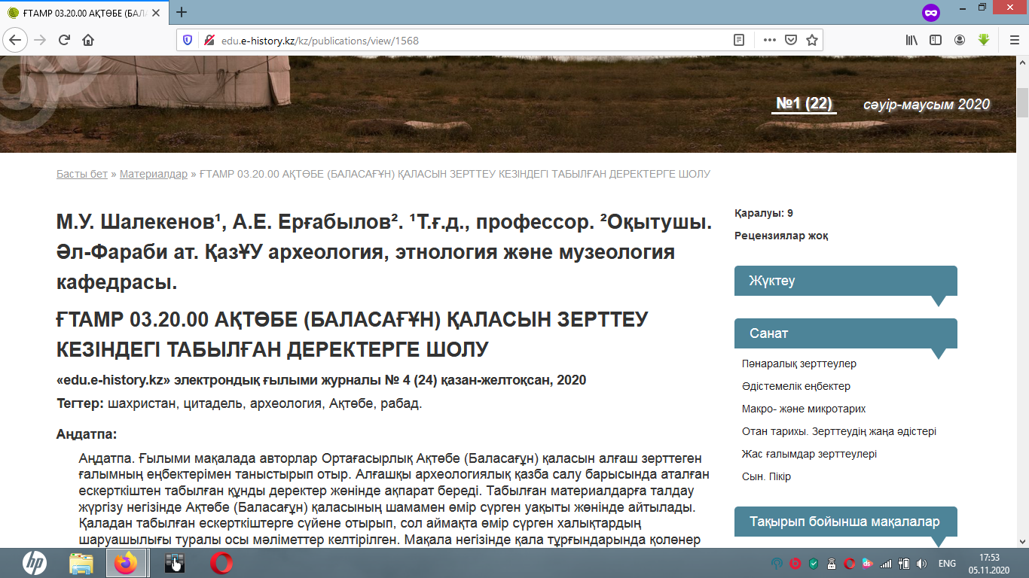
http://edu.e-history.kz/kz/publications/view/1568

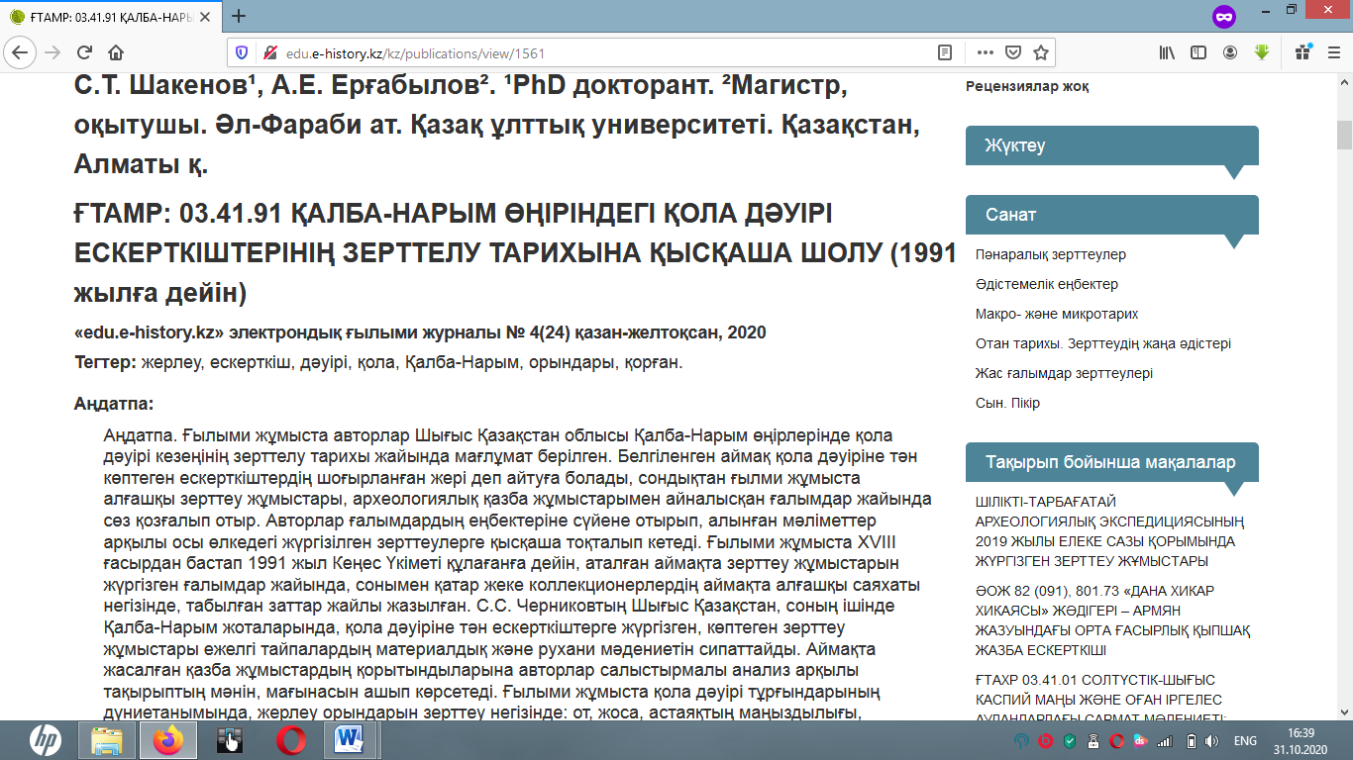
http://edu.e-history.kz/kz/publications/view/1561

